JOB DESCRIPTION

JOB TITLE: Metropolitan Youth Orchestra Administrative Assistant
DEPARTMENT: Education and Community Engagement
REPORTS TO: Director of Metropolitan Youth Orchestra

POSITION SUMMARY: The MYO Administrative Assistant will be responsible for all administrative tasks associated with the program – working with ISO staff, MYO families, Teaching Artists, as well as supporting the Director. This person will be self-motivated and can anticipate needs based on the season calendar. The position requires versatility and flexibility with proven organizational skills.

REPRESENTATIVE DUTIES AND RESPONSIBILITIES:
- Schedule appointments and assist with any hiring needs
- Coordinate and prep materials for teacher meetings, family orientation, orchestra rehearsals etc.
- Prepare communications, such as family emails, invoices, check requests, tuition reports and other correspondence
- Create or manage online filing systems including music library
- Create and manage MYO social media posts and proactively provide updates for website changes to the Marketing Department.
- Act as liaison between families and students, as well as between MYO and key personnel at the ISO.
- Coordinate with outside vendors and partners
- Communicate all opportunities in a timely manner including but not limited to volunteering, concert tickets, and application deadlines.
- Act as an ambassador for MYO, ensuring all parties receive information for programs.
- Maintain a streamlined process around data and payment management including constituent records, billing, registration, and payment processing. Evaluate existing processes and propose improvements and revamps as deemed necessary.
- Communicate with teachers regarding lessons hours and work with HR to ensure payroll is submitted on time.
- Be knowledgeable about all aspects of MYO & ISO activities, calendar, and events as well as how they fit into the overall ISO organization mission.
- Anticipate and support event-planning needs such as facilities setup and supply purchasing.
- Represent the MYO, the ISO and the Education and Community Engagement Department to staff, musicians, teachers and community members in a professional manner.
- Provide any assistance to other Education and Community Engagement staff and events as needed.
- Perform other duties as assigned.

MINIMUM REQUIREMENTS
- Background knowledge of orchestral instrumentations is desirable.
- Ability to work with a diverse group of people
- Demonstrated commitment to valuing diversity and contributing to an inclusive working and learning environment
- One to three years of experience in administrative work, or similar work.
- Ability to maintain a flexible schedule – requires evening, weekend, and off-site work at various times through the season.
- Competency with learning new software. Systems used in this position may include Tessitura, Da Capo Instrument system, Canva, Formstack, Signup Genius, and Wordfly. Proficiency in MS Office is required especially Excel.
- Strong organizational skills with attention to detail and ability to anticipate tasks and communicate proactively.

INTERPERSONAL CONTACTS:
INTERNAL: Regular contact with MYO teachers, students, key ISO personnel
EXTERNAL: Extensive personal contact with parents and community members.
CONTENT OF CONFIDENTIAL INFORMATION: Information regarding internal and external events and people, and sensitive financial information.

SUPERVISION: Oversee volunteers as needed.

MYOrchestra MYFamily MYFuture
The Metropolitan Youth Orchestra (MYO) is a youth and family development program of the Indianapolis Symphony Orchestra. For over 25 years, the MYO program has been all about developing life skills through the rehearsal and performance of music. Students are provided a safe and loving environment to make mistakes, overcome fears, develop healthy relationships, fulfill their potential, and take the life skills learned through music to become successful adults.

MYO VALUES

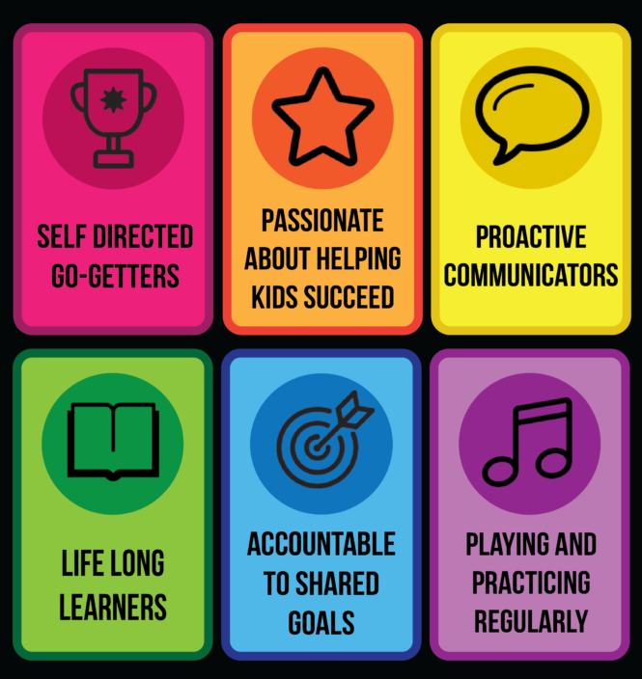

ISO MISSION
To inspire, entertain, educate and challenge through innovative programs and symphonic music performed at the highest artistic level.

ISO VALUES
At the Indianapolis Symphony Orchestra, we are one team committed to achieving our mission through:
- Outstanding performance on and off the stage.
- Extraordinary service to both internal and external customers.
- A compassionate workplace built on trust and mutual respect.
- A culture of flexibility and openness to change.

The Indianapolis Symphony Orchestra is proud to be an Equal Opportunity Employer. All qualified applicants will receive consideration without regard to race, color, religion, gender, national origin, age, disability, sexual orientation, veteran status or any other status protected by law.

Applications for this position should be sent to
jobs@indianapolissymphony.org
(Please include a cover letter and resume.)

